**Fields of Inquiry**

**Culture, identity and community**

How texts explore aspects of family, class, race, ethnicity, nationality, religion, gender and sexuality, and the way these impact on individuals and societies. They might also focus on issues concerning migration, colonialism and nationalism.

**Beliefs, values and education**

How texts explore the beliefs and values nurtured in particular societies and the ways they shape individuals, communities and educational systems. They might also explore the tensions that arise when there are conflicts of beliefs and values, or ethics.

**Politics, power and justice**

How texts explore aspects of rights and responsibilities, the workings and structures of governments and institutions. They might also investigate hierarchies of power, the distribution of wealth and resources, the limits of justice and the law, equality and inequality, human rights and peace and conflict.

**Art, creativity and the imagination**

How texts explore aspects of aesthetic inspiration, creation, craft, and beauty. They might also focus on the shaping and challenging of perceptions through art, and the function, value and effects of art in society.

**Science, technology and the natural world**

How texts explore the relationship between humans and the environment and the implications of technology and media for society. They might also consider the idea of scientific development and progress.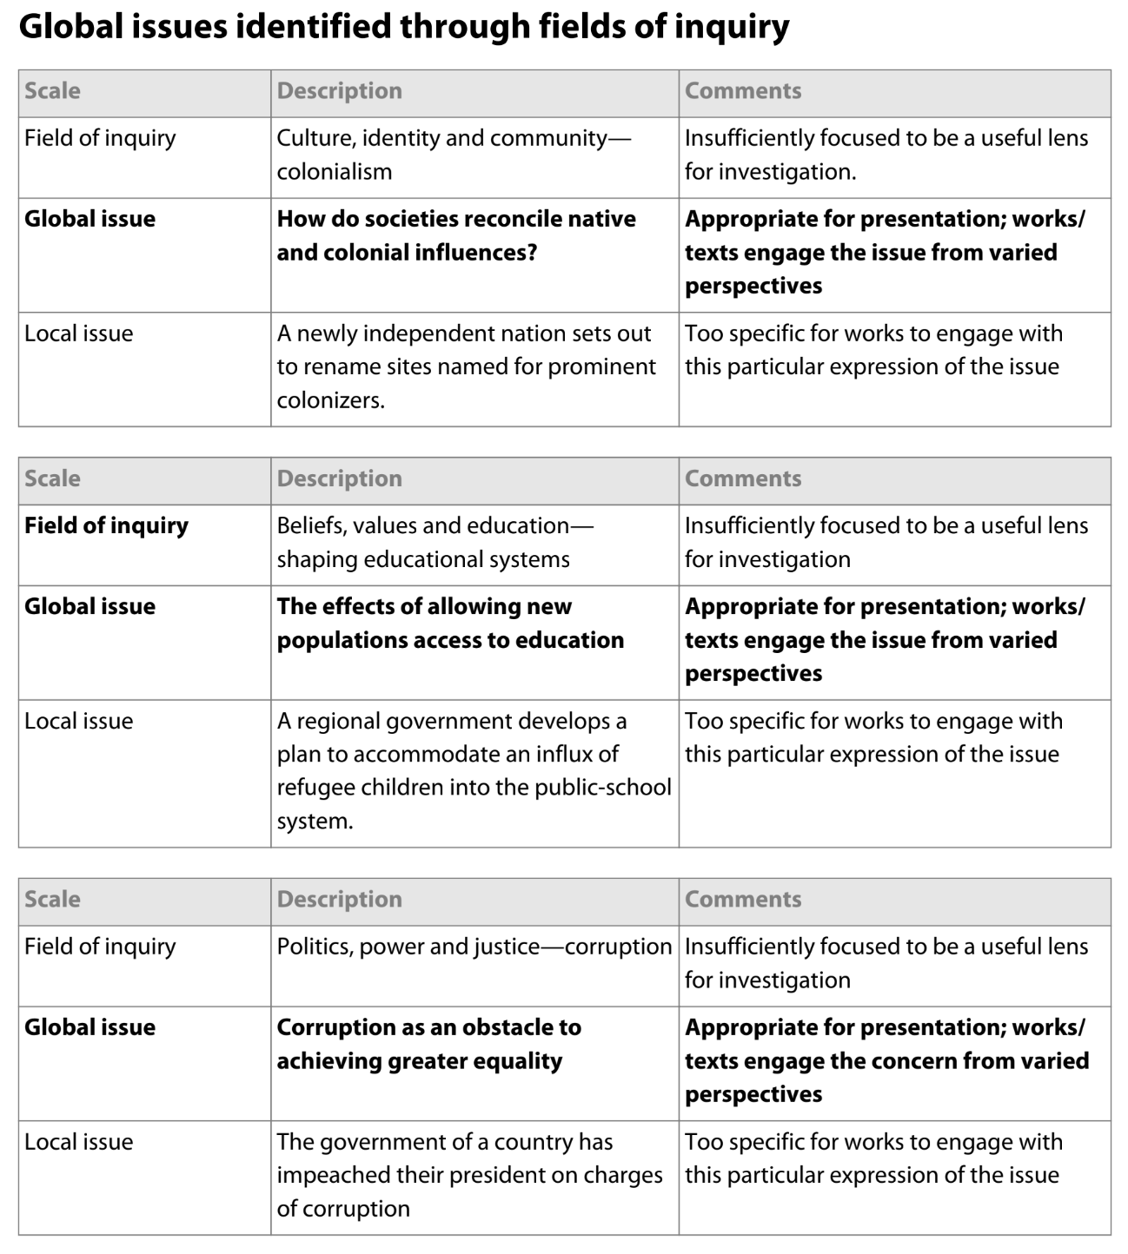

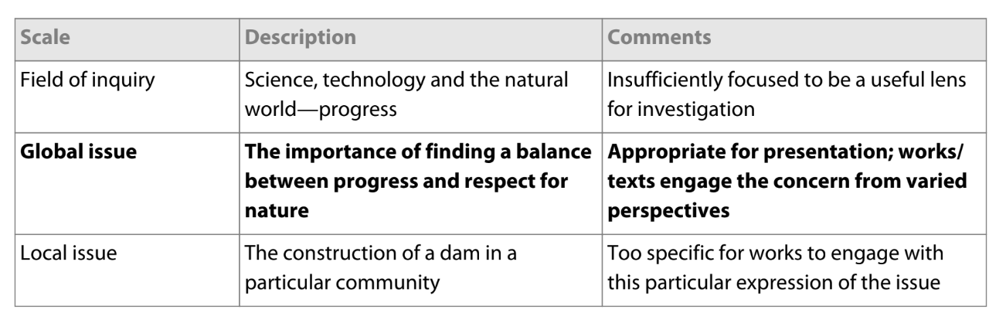

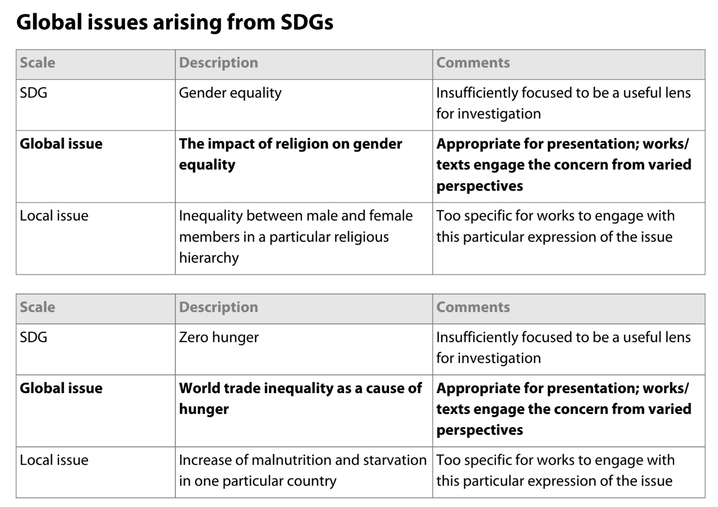

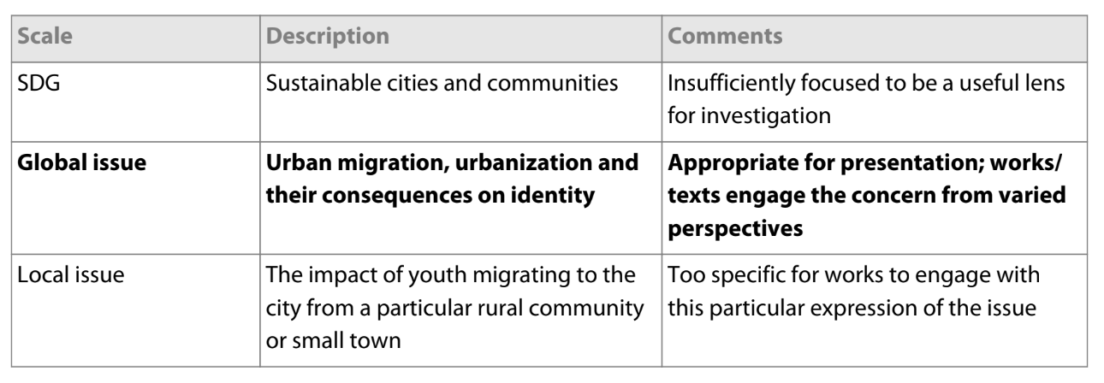

**\*\*\*Please note this information is taken from the IB Language A: language and literature guide, First assessment 2021**